**UNIT-I INTRODUCTION**

**Concept of control system**

A **control system** manages commands, directs or regulates the behavior of other devices or systems using [control loops.](https://en.wikipedia.org/wiki/Control_loop) It can range from a single home heating controller using a [thermostat](https://en.wikipedia.org/wiki/Thermostat) controlling a domestic boiler to large [Industrial control systems](https://en.wikipedia.org/wiki/Industrial_control_system) which are used for controlling [processes](https://en.wikipedia.org/wiki/Process_(engineering)) or machines. A control system is a system, which provides the desired response by controlling the output. The following figure shows the simple block diagram of a control system.

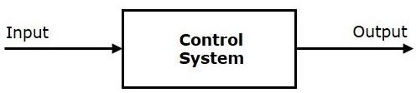

**Examples** − Traffic lights control system, washing machine

**Traffic lights control system** is an example of control system. Here, a sequence of input signal is applied to this control system and the output is one of the three lights that will be on for some duration of time. During this time, the other two lights will be off. Based on the traffic study at a particular junction, the on and off times of the lights can be determined. Accordingly, the input signal controls the output. So, the traffic lights control system operates on time basis.

## Classification of Control Systems

Based on some parameters, we can classify the control systems into the following ways.

## Continuous time and Discrete-time Control Systems

* + Control Systems can be classified as continuous time control systems and discrete time control systems based on the **type of the signal** used.
  + In **continuous time** control systems, all the signals are continuous in time. But, in **discrete time** control systems, there exists one or more discrete time signals.

## SISO and MIMO Control Systems

* + Control Systems can be classified as SISO control systems and MIMO control systems based on the **number of inputs and outputs** present.
  + **SISO** (Single Input and Single Output) control systems have one input and one output. Whereas, **MIMO** (Multiple Inputs and Multiple Outputs) control systems have more than one input and more than one output.

## Open Loop and Closed Loop Control Systems

Control Systems can be classified as open loop control systems and closed loop control systems based on the **feedback path**.

In **open loop control systems**, output is not fed-back to the input. So, the control action is independent of the desired output.

The following figure shows the block diagram of the open loop control system.

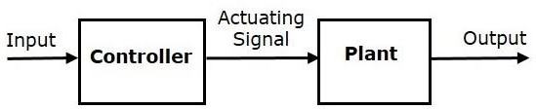

Here, an input is applied to a controller and it produces an actuating signal or controlling signal. This signal is given as an input to a plant or process which is to be controlled. So, the plant produces an output, which is controlled. The traffic lights control system which we discussed earlier is an example of an open loop control system.

In **closed loop control systems**, output is fed back to the input. So, the control action is dependent on the desired output.

The following figure shows the block diagram of negative feedback closed loop control system.

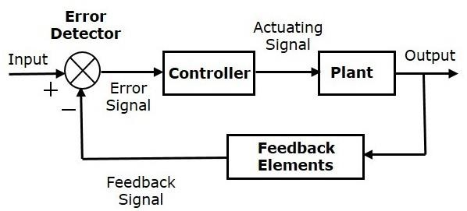

The error detector produces an error signal, which is the difference between the input and the feedback signal. This feedback signal is obtained from the block (feedback elements) by considering the output of the overall system as an input to this block. Instead of the direct input, the error signal is applied as an input to a controller.

So, the controller produces an actuating signal which controls the plant. In this combination, the output of the control system is adjusted automatically till we get the desired response. Hence, the closed loop control systems are also called the automatic control systems. Traffic lights control system having sensor at the input is an example of a closed loop control system.

The differences between the open loop and the closed loop control systems are mentioned in the following table.

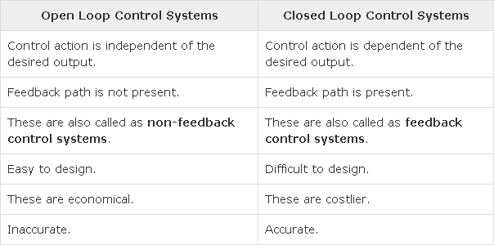

If either the output or some part of the output is returned to the input side and utilized as part of the system input, then it is known as **feedback**. Feedback plays an important role in order to improve the performance of the control systems. In this chapter, let us discuss the types of feedback & effects of feedback.

## Types of Feedback

There are two types of feedback −

* + Positive feedback
  + Negative feedback

## Positive Feedback

The positive feedback adds the reference input, R(s)R(s) and feedback output. The following figure shows the block diagram of **positive feedback control system**

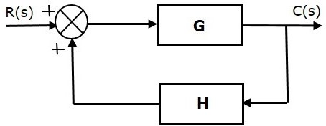

he concept of transfer function will be discussed in later chapters. For the time being, consider the transfer function of positive feedback control system is,

Where,

* + **T** is the transfer function or overall gain of positive feedback control system.
  + **G** is the open loop gain, which is function of frequency.
  + **H** is the gain of feedback path, which is function of frequency.

## Negative Feedback

Negative feedback reduces the error between the reference input, R(s)R(s) and system output. The following figure shows the block diagram of the **negative feedback control system**.

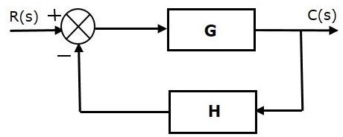

Transfer function of negative feedback control system is,



Where,

* + **T** is the transfer function or overall gain of negative feedback control system.
  + **G** is the open loop gain, which is function of frequency.
  + **H** is the gain of feedback path, which is function of frequency.

The derivation of the above transfer function is present in later chapters.

## Effects of Feedback

Let us now understand the effects of feedback.

## Effect of Feedback on Overall Gain

* + From Equation 2, we can say that the overall gain of negative feedback closed loop control system is the ratio of 'G' and (1+GH). So, the overall gain may increase or decrease depending on the value of (1+GH).
  + If the value of (1+GH) is less than 1, then the overall gain increases. In this case, 'GH' value is negative because the gain of the feedback path is negative.
  + If the value of (1+GH) is greater than 1, then the overall gain decreases. In this case, 'GH' value is positive because the gain of the feedback path is positive.

In general, 'G' and 'H' are functions of frequency. So, the feedback will increase the overall gain of the system in one frequency range and decrease in the other frequency range.

## Effect of Feedback on Sensitivity

**Sensitivity** of the overall gain of negative feedback closed loop control system (**T**) to the variation in open loop gain (**G**) is defined as

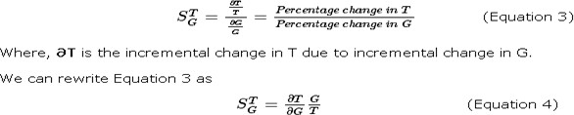

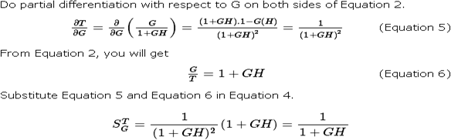

So, we got the **sensitivity** of the overall gain of closed loop control system as the reciprocal of (1+GH). So, Sensitivity may increase or decrease depending on the value of (1+GH).

* + If the value of (1+GH) is less than 1, then sensitivity increases. In this case, 'GH' value is negative because the gain of feedback path is negative.
  + If the value of (1+GH) is greater than 1, then sensitivity decreases. In this case, 'GH' value is positive because the gain of feedback path is positive.

In general, 'G' and 'H' are functions of frequency. So, feedback will increase the sensitivity of the system gain in one frequency range and decrease in the other frequency range. Therefore, we have to choose the values of 'GH' in such a way that the system is insensitive or less sensitive to parameter variations.

## Effect of Feedback on Stability

* + A system is said to be stable, if its output is under control. Otherwise, it is said to be unstable.
  + In Equation 2, if the denominator value is zero (i.e., GH = -1), then the output of the control system will be infinite. So, the control system becomes unstable.

Therefore, we have to properly choose the feedback in order to make the control system stable.

## Effect of Feedback on Noise

To know the effect of feedback on noise, let us compare the transfer function relations with and without feedback due to noise signal alone.

Consider an **open loop control system** with noise signal as shown below.

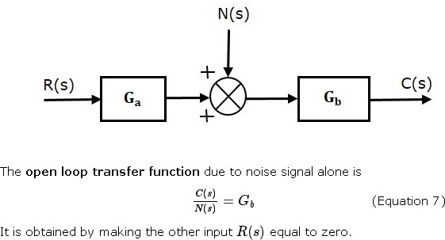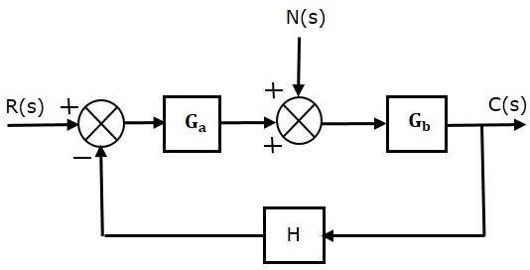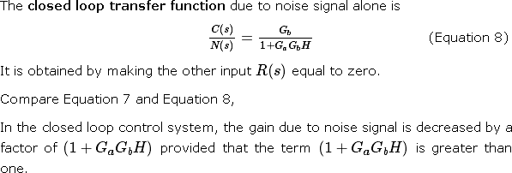

The control systems can be represented with a set of mathematical equations known as **mathematical model**. These models are useful for analysis and design of control systems. Analysis of control system means finding the output when we know the input and mathematical model. Design of control system means finding the mathematical model when we know the input and the output.

The following mathematical models are mostly used.

* + Differential equation model
  + Transfer function model
  + State space model

## TRANSFER FUNCTION REPRESENTATION

**Block Diagrams**

Block diagrams consist of a single block or a combination of blocks. These are used to represent the control systems in pictorial form.

## Basic Elements of Block Diagram

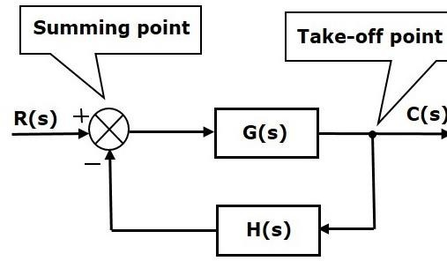The basic elements of a block diagram are a block, the summing point and the take-off point. Let us consider the block diagram of a closed loop control system as shown in the following figure to identify these elements.

The above block diagram consists of two blocks having transfer functions G(s) and H(s). It is also having one summing point and one take-off point. Arrows indicate the direction of the flow of signals. Let us now discuss these elements one by one.

## Block

The transfer function of a component is represented by a block. Block has single input and single output.

The following figure shows a block having input X(s), output Y(s) and the transfer function G(s).

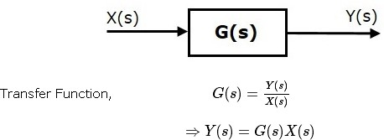

## Summing Point

The summing point is represented with a circle having cross (X) inside it. It has two or more inputs and single output. It produces the algebraic sum of the inputs. It also performs the summation or subtraction or combination of summation and subtraction of the inputs based on the polarity of the inputs. Let us see these three operations one by one.

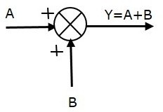The following figure shows the summing point with two inputs (A, B) and one output (Y). Here, the inputs A and B have a positive sign. So, the summing point produces the output, Y as **sum of A and B** i.e. = A + B.

The following figure shows the summing point with two inputs (A, B) and one output (Y). Here, the inputs A and B are having opposite signs, i.e., A is having positive sign and B is having negative sign. So, the summing point produces the output **Y** as the **difference of A and B** i.e

Y = A + (-B) = A - B.

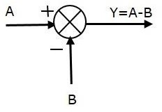

The following figure shows the summing point with three inputs (A, B, C) and one output (Y). Here, the inputs A and B are having positive signs and C is having a negative sign. So, the summing point produces the output **Y** as

Y = A + B + (−C) = A + B − C.

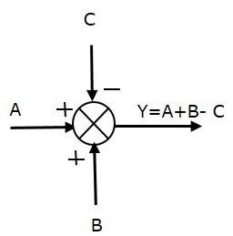

## Take-off Point

The take-off point is a point from which the same input signal can be passed through more than one branch. That means with the help of take-off point, we can apply the same input to one or more blocks, summing points.In the following figure, the take-off point is used to connect the same input, R(s) to two more blocks.

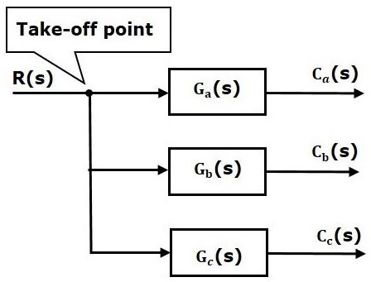

In the following figure, the take-off point is used to connect the output C(s), as one of the inputs to the summing point.

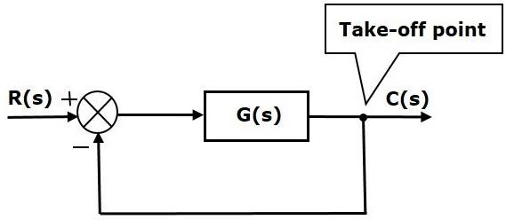

Block diagram algebra is nothing but the algebra involved with the basic elements of the block diagram. This algebra deals with the pictorial representation of algebraic equations.

## Basic Connections for Blocks

There are three basic types of connections between two blocks.

## Series Connection

Series connection is also called **cascade connection**. In the following figure, two blocks having transfer functions G1(s)G1(s) and G2(s)G2(s) are connected in series.

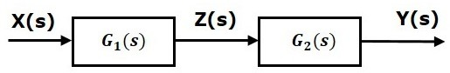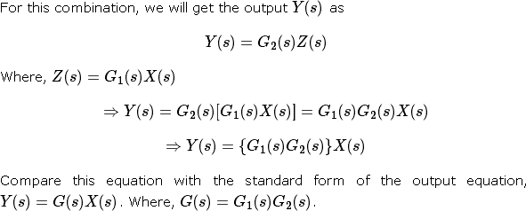

That means we can represent the **series connection** of two blocks with a single block. The transfer function of this single block is the **product of the transfer functions** of those two blocks. The equivalent block diagram is shown below.

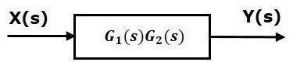

Similarly, you can represent series connection of ‘n’ blocks with a single block. The transfer function of this single block is the product of the transfer functions of all those ‘n’ blocks.

## Parallel Connection

The blocks which are connected in **parallel** will have the **same input**. In the following figure, two blocks having transfer functions G1(s)G1(s) and G2(s)G2(s) are connected in parallel. The outputs of these two blocks are connected to the summing point.

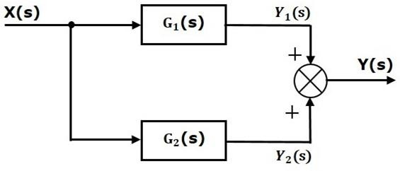

That means we can represent the **parallel connection** of two blocks with a single block. The transfer function of this single block is the **sum of the transfer functions** of those two blocks. The equivalent block diagram is shown below.

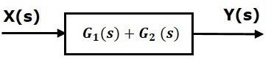

Similarly, you can represent parallel connection of ‘n’ blocks with a single block. The transfer function of this single block is the algebraic sum of the transfer functions of all those ‘n’ blocks.

## Feedback Connection

As we discussed in previous chapters, there are two types of **feedback** — positive feedback and negative feedback. The following figure shows negative feedback control system. Here, two blocks having transfer functions G(s)G(s) and H(s)H(s) form a closed loop.

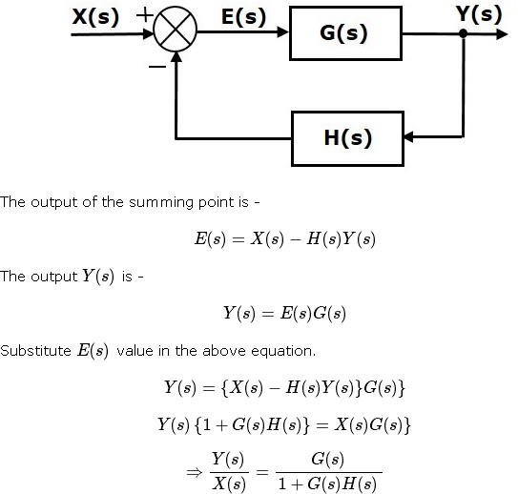

Therefore, the negative feedback closed loop transfer function is :

This means we can represent the negative feedback connection of two blocks with a single block. The transfer function of this single block is the closed loop transfer function of the negative feedback. The equivalent block diagram is shown below.

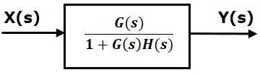

Similarly, you can represent the positive feedback connection of two blocks with a single block. The transfer function of this single block is the closed loop transfer function of the positive feedback, i.e.,



## Block Diagram Algebra for Summing Points

There are two possibilities of shifting summing points with respect to blocks −

* + Shifting summing point after the block
  + Shifting summing point before the block

Let us now see what kind of arrangements need to be done in the above two cases one by one.

## Shifting the Summing Point before a Block to after a Block

Consider the block diagram shown in the following figure. Here, the summing point is present before the block.

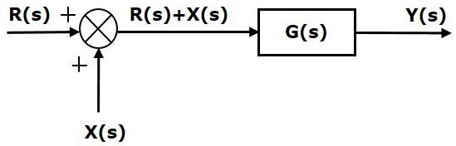



The output of Summing point is

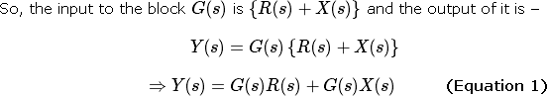

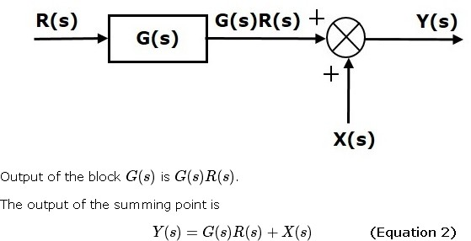

Compare Equation 1 and Equation 2.

The first term ‘G(s)R(s)′‘G(s)R(s)′ is same in both the equations. But, there is difference in the second term. In order to get the second term also same, we require one more block G(s)G(s). It is having the input X(s)X(s) and the output of this block is given as input to summing point instead of X(s)X(s). This block diagram is shown in the following figure.

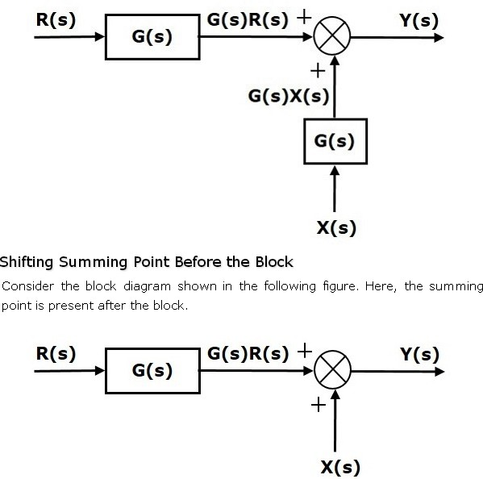

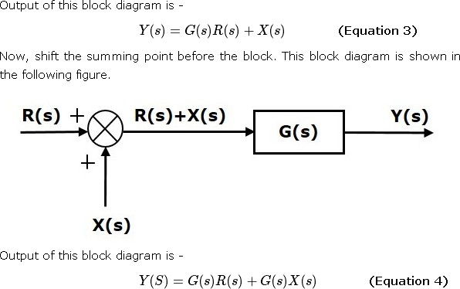

Compare Equation 3 and Equation 4,

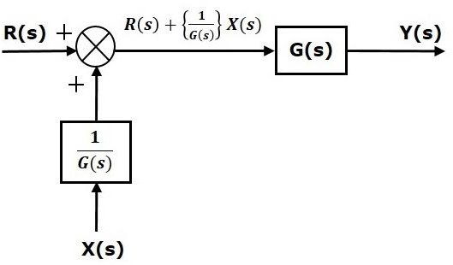The first term ‘G(s)R(s)′ is same in both equations. But, there is difference in the second term. In order to get the second term also same, we require one more block 1/G(s). It is having the input X(s) and the output of this block is given as input to summing point instead of X(s). This block diagram is shown in the following figure.

## Block Diagram Algebra for Take-off Points

There are two possibilities of shifting the take-off points with respect to blocks −

* + Shifting take-off point after the block
  + Shifting take-off point before the block

Let us now see what kind of arrangements is to be done in the above two cases, one by one.

## Shifting a Take-off Point form a Position before a Block to a position after the Block

Consider the block diagram shown in the following figure. In this case, the take-off point is present before the block.

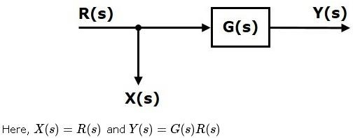

When you shift the take-off point after the block, the output Y(s) will be same. But, there is difference in X(s) value. So, in order to get the same X(s) value, we require one more block 1/G(s). It is having the input Y(s) and the output is X(s) this block diagram is shown in the following figure.

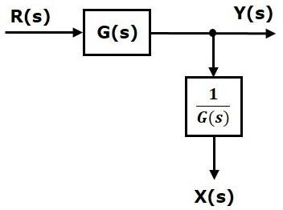

## Shifting Take-off Point from a Position after a Block to a position before the Block

Consider the block diagram shown in the following figure. Here, the take-off point is present after the block.

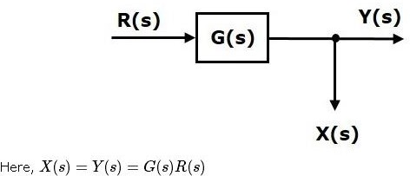

When you shift the take-off point before the block, the output Y(s) will be same. But, there is difference in X(s) value. So, in order to get same X(s) value, we require one more block G(s) It is having the input R(s) and the output is X(s). This block diagram is shown in the following figure.

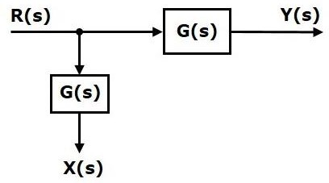

The concepts discussed in the previous chapter are helpful for reducing (simplifying) the block diagrams.

## Block Diagram Reduction Rules

Follow these rules for simplifying (reducing) the block diagram, which is having many blocks, summing points and take-off points.

* + **Rule 1** − Check for the blocks connected in series and simplify.
  + **Rule 2** − Check for the blocks connected in parallel and simplify.
  + **Rule 3** − Check for the blocks connected in feedback loop and simplify.
  + **Rule 4** − If there is difficulty with take-off point while simplifying, shift it towards right.
  + **Rule 5** − If there is difficulty with summing point while simplifying, shift it towards left.
  + **Rule 6** − Repeat the above steps till you get the simplified form, i.e., single block.

**Note** − The transfer function present in this single block is the transfer function of the overall block diagram.

## Example

Consider the block diagram shown in the following figure. Let us simplify (reduce) this block diagram using the block diagram reduction rules.

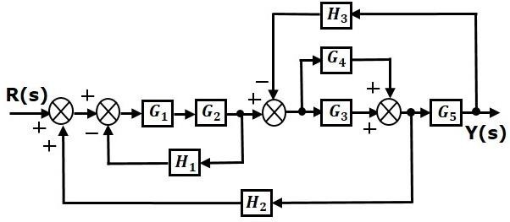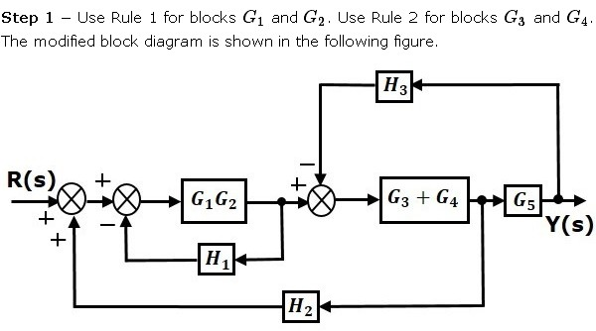

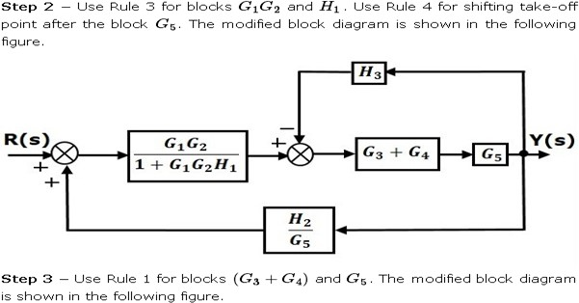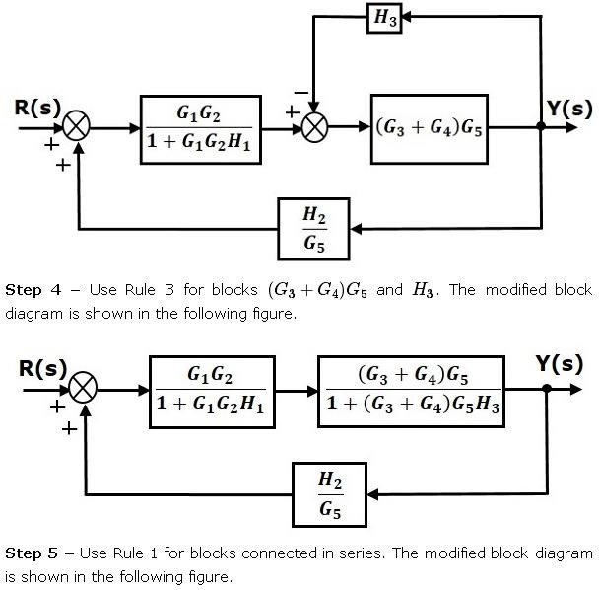

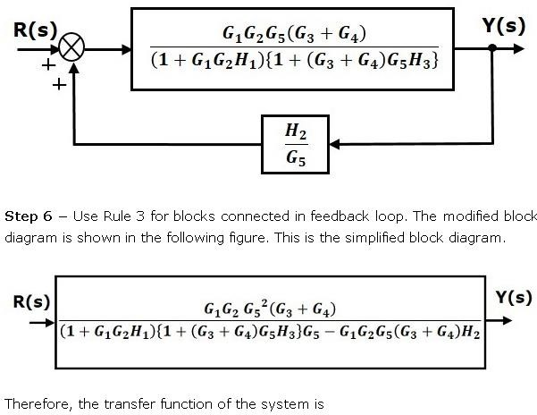

**Note** − Follow these steps in order to calculate the transfer function of the block diagram having multiple inputs.

* + **Step 1** − Find the transfer function of block diagram by considering one input at a time and make the remaining inputs as zero.
  + **Step 2** − Repeat step 1 for remaining inputs.
  + **Step 3** − Get the overall transfer function by adding all those transfer functions.

The block diagram reduction process takes more time for complicated systems because; we have to draw the (partially simplified) block diagram after each step. So, to overcome this drawback, use signal flow graphs (representation).

## Block Diagram Reduction- Summary



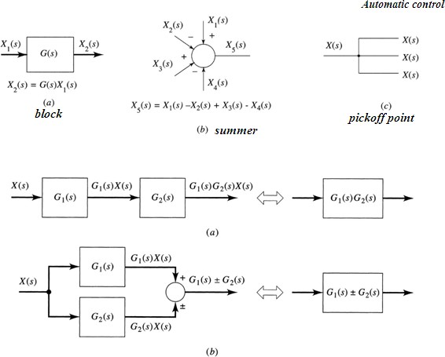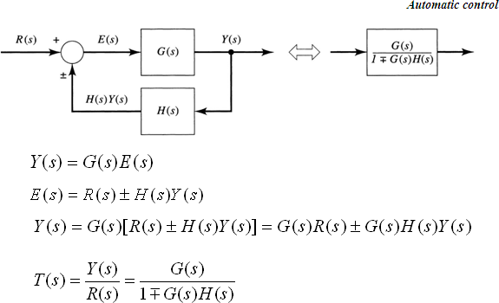

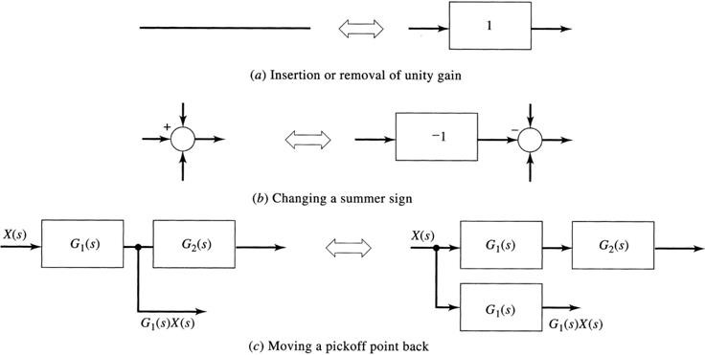

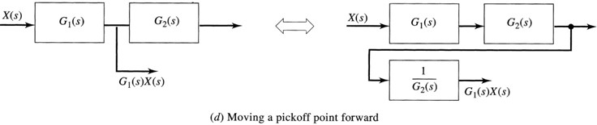

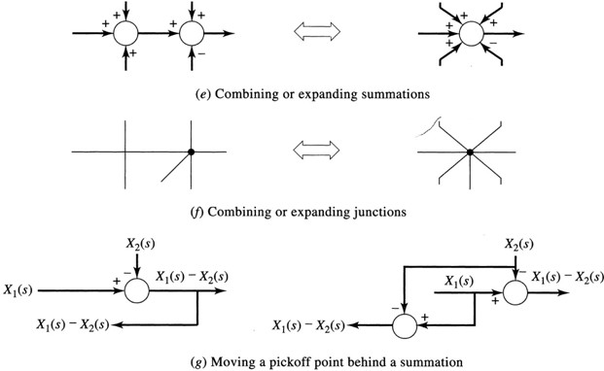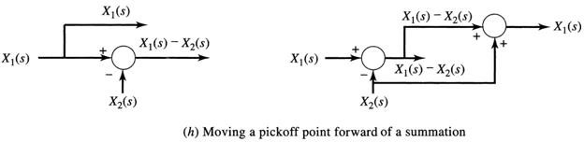

Example-1:

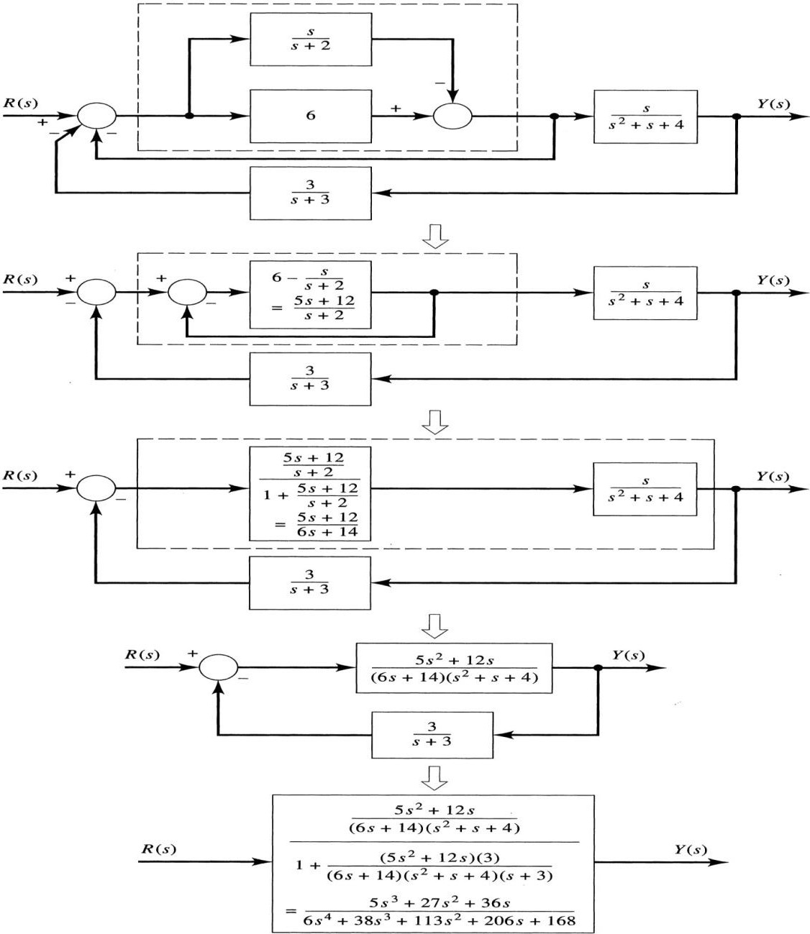

## Example-2:

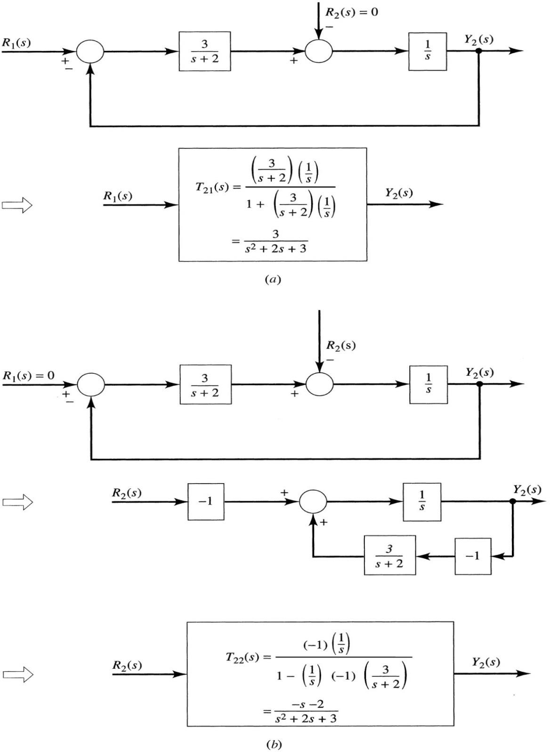

Signal flow graph is a graphical representation of algebraic equations. In this chapter, let us discuss the basic concepts related signal flow graph and also learn how to draw signal flow graphs.

## Basic Elements of Signal Flow Graph

Nodes and branches are the basic elements of signal flow graph. Node

**Node** is a point which represents either a variable or a signal. There are three types of nodes

* input node, output node and mixed node.
  + **Input Node** − It is a node, which has only outgoing branches.
  + **Output Node** − It is a node, which has only incoming branches.
  + **Mixed Node** − It is a node, which has both incoming and outgoing branches.

## Example

Let us consider the following signal flow graph to identify these nodes.

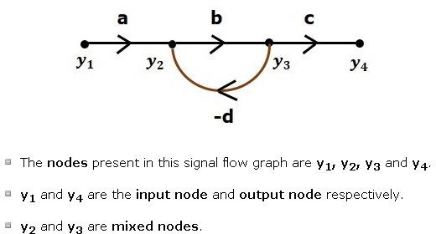

## Branch

**Branch** is a line segment which joins two nodes. It has both **gain** and **direction**. For example, there are four branches in the above signal flow graph. These branches have **gains** of **a, b, c** and **-d**.

## Construction of Signal Flow Graph

Let us construct a signal flow graph by considering the following algebraic equations −

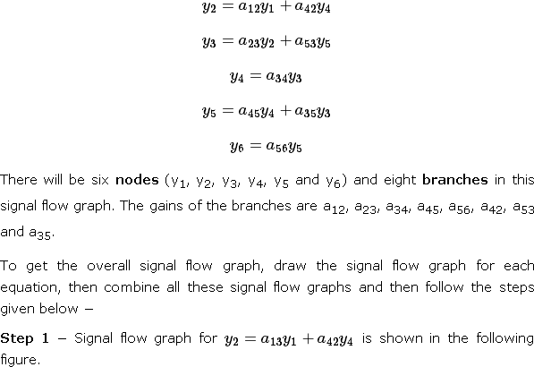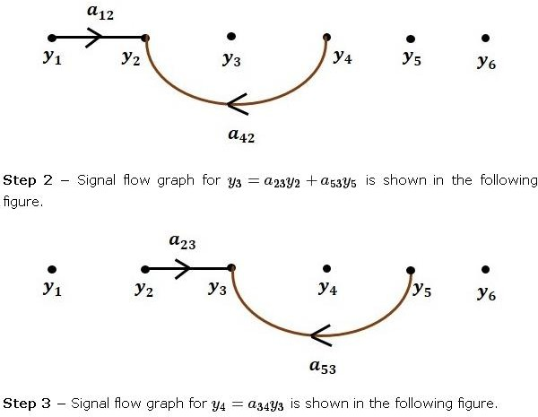

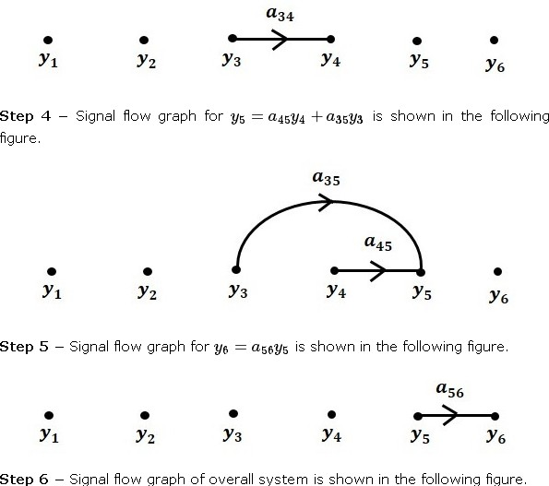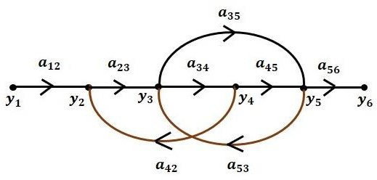

## Conversion of Block Diagrams into Signal Flow Graphs

Follow these steps for converting a block diagram into its equivalent signal flow graph.

* + Represent all the signals, variables, summing points and take-off points of block diagram as **nodes** in signal flow graph.
  + Represent the blocks of block diagram as **branches** in signal flow graph.
  + Represent the transfer functions inside the blocks of block diagram as**gains** of the branches in signal flow graph.
  + Connect the nodes as per the block diagram. If there is connection between two nodes (but there is no block in between), then represent the gain of the branch as one. **For example**, between summing points, between summing point and takeoff point, between input and summing point, between take-off point and output.

## Example

Let us convert the following block diagram into its equivalent signal flow graph.

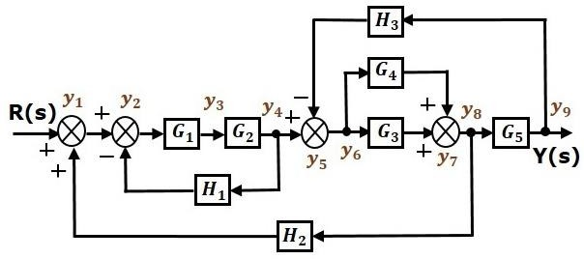

Represent the input signal R(s) and output signal C(s) of block diagram as input node R(s) and output node C(s) of signal flow graph.

Just for reference, the remaining nodes (y1 to y9) are labelled in the block diagram. There are nine nodes other than input and output nodes. That is four nodes for four summing points, four nodes for four take-off points and one node for the variable between blocks G1and G2.

The following figure shows the equivalent signal flow graph.

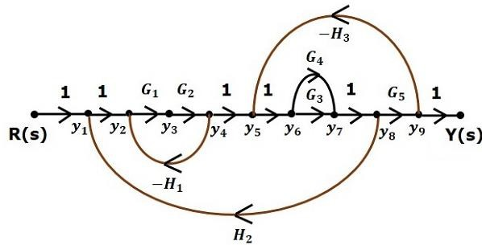

Let us now discuss the Mason’s Gain Formula. Suppose there are ‘N’ forward paths in a signal flow graph. The gain between the input and the output nodes of a signal flow graph is nothing but the **transfer function** of the system. It can be calculated by using Mason’s gain formula.

## Mason’s gain formula is



Where,

* + **C(s)** is the output node
  + **R(s)** is the input node
  + **T** is the transfer function or gain between R(s) and C(s)
  + **Pi** is the ith forward path gain

Δ=1−(sum of all individual loop gains) +(sum of gain products of all possible two nontouching loops)−(sum of gain products of all possible three nontouching loops) +….

Δi is obtained from Δ by removing the loops which are touching the ith forward path.

Consider the following signal flow graph in order to understand the basic terminology involved here.

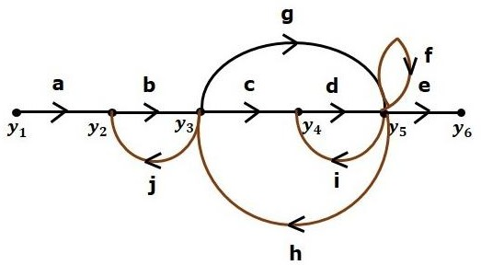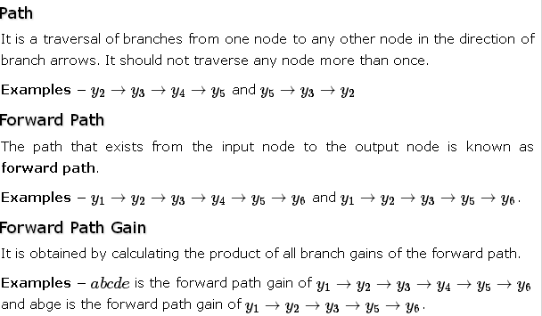

## Loop

The path that starts from one node and ends at the same node is known as a **loop**. Hence, it is a closed path.

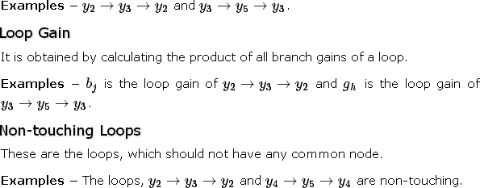

Calculation of Transfer Function using Mason’s Gain Formula

Let us consider the same signal flow graph for finding transfer function.

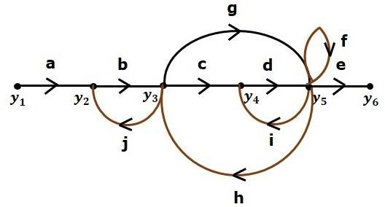

* + Number of forward paths, N = 2.
  + First forward path is - y1→y2→y3→y4→y5→y6.
  + First forward path gain, p1=abcde
  + Second forward path is - y1→y2→y3→y5→y6
  + Second forward path gain, p2=abge
  + Number of individual loops, L = 5.

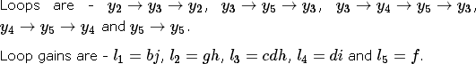

* + Number of two non-touching loops = 2.
  + First non-touching loops pair is - y2→y3→y2, y4→y5→y4.
  + Gain product of first non-touching loops pair l1l4=bjdi
  + Second non-touching loops pair is - y2→y3→y2, y5→y5.
  + Gain product of second non-touching loops pair is l1l5=bjf

Higher number of (more than two) non-touching loops are not present in this signal flow graph.We know,

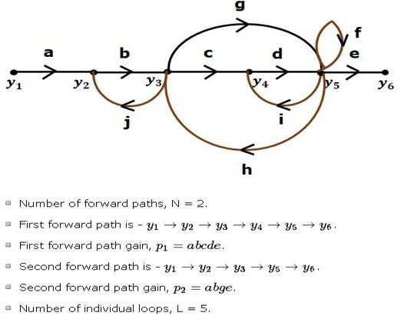

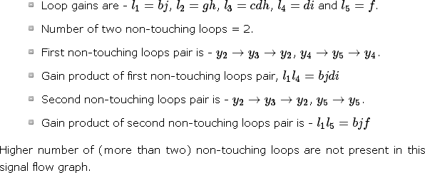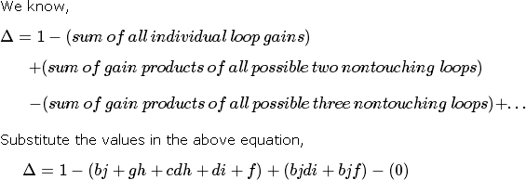

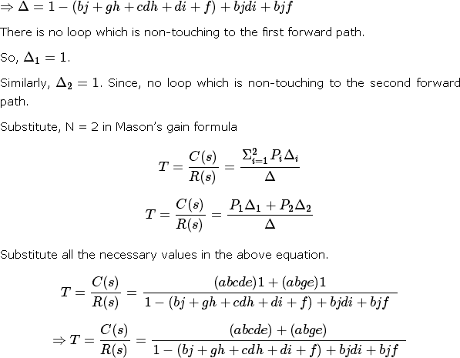

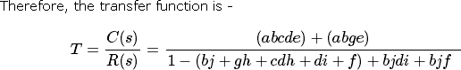

Example-1:

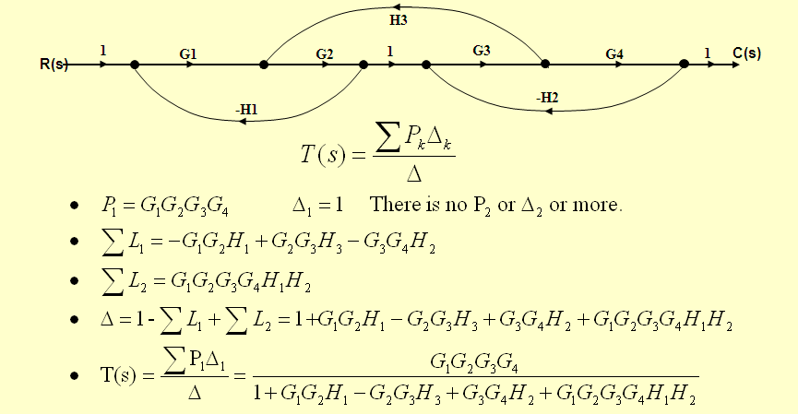

Example-2:

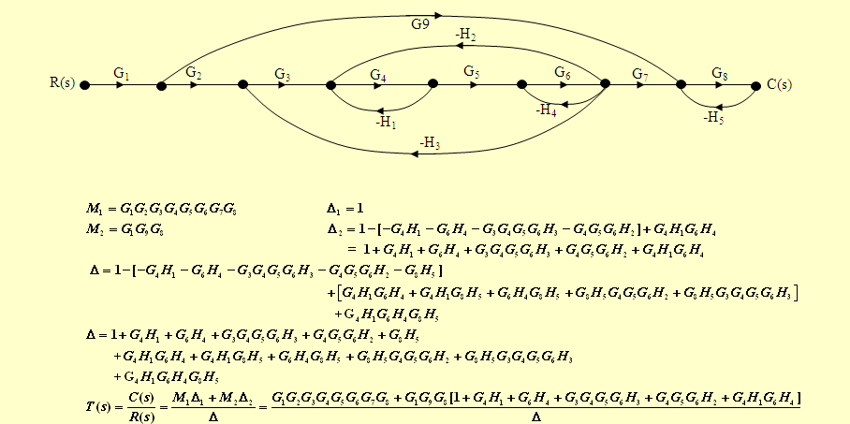

Example-3:

